PBL Secondary Research Report

(FPGA-Based Design Project)
Title:
FPGA-Based Image Blur Filter using Parallel Matrix Computation

Chapter 1: Introduction

Background :
In recent years, many modern applications such as biomedical signal analysis, climate modelling, and artificial intelligence rely heavily on matrix computations. These computations form the core of operations like image processing, pattern recognition, and data analysis.

One important operation in image processing is image blurring, which is used to reduce noise and smooth images. This is commonly done using convolution, which involves matrix multiplication between an image and a kernel.

However, performing such matrix operations using software is time-consuming and consumes more power, especially in real-time and embedded systems. FPGA (Field Programmable Gate Array) provides a hardware-based solution where parallel processing can be used to perform multiple computations at the same time, thereby improving speed and efficiency.

Problem Statement:
Modern applications such as biomedical signal analysis, climate modelling, and artificial intelligence rely heavily on matrix computations. However, software-based matrix operations, especially matrix multiplication, consume high computational time and energy, making them inefficient for real-time and embedded systems.

In image processing, operations like blurring involve matrix-based computations (convolution), which further increase processing complexity when handled sequentially.

Therefore, there is a need to develop an efficient hardware-based solution using FPGA that can improve the performance and energy efficiency of matrix computations. This project focuses on designing an FPGA-based image blur filter using parallel matrix computation to achieve faster processing compared to traditional sequential methods.

Objectives:
- To design an image blur filter using FPGA
- To implement parallel matrix computation for faster processing
- To reduce execution time compared to sequential methods
- To improve energy efficiency in computation
- To simulate and verify the design

Chapter 2: Literature Review (Secondary Research)

2.1 Review of Existing Work:
Several research works have been done on FPGA-based image processing systems. Most of these systems use convolution techniques for filtering operations like blurring, sharpening, and edge detection.

Traditional implementations use sequential processing, where each pixel is processed one after another. While this method is simple, it is not efficient for large-scale or real-time applications.

Recent works focus on parallel architectures using FPGA, where multiple computations are carried out simultaneously. Techniques like pipelining and parallel matrix multiplication have shown significant improvements in speed.

2.2 Comparative Analysis:

PAPER | ARCHITECTURE USED | THROUGHPUT | AREA  (RESOURCE UTILIZATION) | LIMITATION
Paper 1  Hardware Implementation of 2D Convolution on FPGA  Dawwd & Fathi | Design-1: Single moving window with pipeline & adder tree.  Design-2: Two parallel windows sharing a 16-bit memory path. | 380 fps  Design-2 · 512×512 · 50 MHz | Slices (Design-1)-254  Slices (Design-2)-338  Max Freq-130 / 128 MHz | Only 3×3, 5×5, 7×7 kernel sizes supported; no arbitrary kernels.  8-bit pixels only; no floating-point support.
Paper 2  An FPGA 2D-Convolution Unit Based on the CAPH Language  Aguilar-González et al. | Circular Buffer + Shift-Based Arithmetic  Replaces multipliers with bit-shift & two's-complement ops.  Circular buffer (10 BRAM cores) feeds reconfigurable convolution stage. | 103 fps  1200×720 · 100 MHz | Logic Elements-8,573  Registers-3,351  Memory Bits-163,840  Multipliers-0 (none)  vs. Conventional-98% less logic | CAPH has limited instantiation support; a manual VHDL wrapper is needed.  No floating-point or low-level bit operations in CAPH.
Paper 3  Real-Time Image Processing with a Compact FPGA-Based Systolic Architecture  Torres-Huitzil & Arias-Estrada | 2D Systolic Array of CWPs  Each CWP: Arithmetic Processor + Local Reduction Module.  Column-based addressing reduces memory overhead. Supports convolution, morphology & template matching via control word | 3.16 GOPs  7×7 array · 60 MHz | Total Slices-6,118 (~30%)  LUTs-10,734  Flip-Flops-1,604  Per CWP-101 slices  Max Freq-60 MHz | CWP efficiency drops as more processors are added — no reutilization mechanism.  Input/output image stored in off-chip memory; bandwidth is a bottleneck.
Paper 4  A High-Performance Fully Reconfigurable FPGA-Based 2D Convolution Processor  Perri, Lanuzza, Corsonello & Cocorullo | 2×2 Grid of SIMD 3×3 Convolvers  Four 16-bit SIMD convolvers operating in parallel. | 228.8 MOPS  8-bit 3×3 · 28.6 MHz | Logic Slices-7,262  FIFO Slices-2,048  Device Usage-~48%  Memory-32 Kbits  Power-102.1 mW/MHz | Supports only 3×3 and 5×5 kernels; larger windows not available.  Low clock frequency (28.6 MHz) compared to modern designs at 100+ MHz.
Proposed work  FPGA-Based 2D Gaussian Averaging Convolution using Pipelined Adder Tree & Line Buffer | Sliding Window + Pipelined Adder Tree + Shift-Divide  Image Memory | ~1 px/clk  One output pixel per clock cycle | Registers / Buffers  Shift Registers-9 × 8-bit (SR1–SR9)  Line Buffer 1-256 × 8-bit  Line Buffer 2-256 × 8-bit  Output Register-8-bit  Compute Units  Adders (Stage 1)-3 × 9-bit  Adders (Stage 2)-2 × 10-bit  Adders (Stage 3)-1 × 11-bit  Estimated FPGA Usage  BRAM blocks-2 (line buffers)  DSP blocks-0  Image Memory-256×256×8 = 512 Kbits | Fixed 3×3 averaging kernel only — no support for edge detection, sharpening or other filter types without redesign.  Fixed image size (256×256); changing resolution requires modifying line buffer depth and address counter.

2.3 Research Gap Identification:
Even though many FPGA-based implementations exist, some limitations are observed:
- Not all designs fully utilize parallel computation
- Some systems consume excessive hardware resources
- Inefficient matrix computation techniques reduce performance gains

This project aims to address these gaps by using optimized parallel matrix computation for image blurring.

Chapter 3: Proposed System Design

3.1 Design Justification:
The proposed system uses FPGA because it allows parallel processing, which significantly improves computational speed. Image blurring is selected as it is a fundamental operation in image processing and involves matrix-based calculations.

By implementing the blur filter using parallel matrix computation, the system can process multiple pixel values at the same time, reducing delay and improving efficiency.

3.2 Block Diagram:

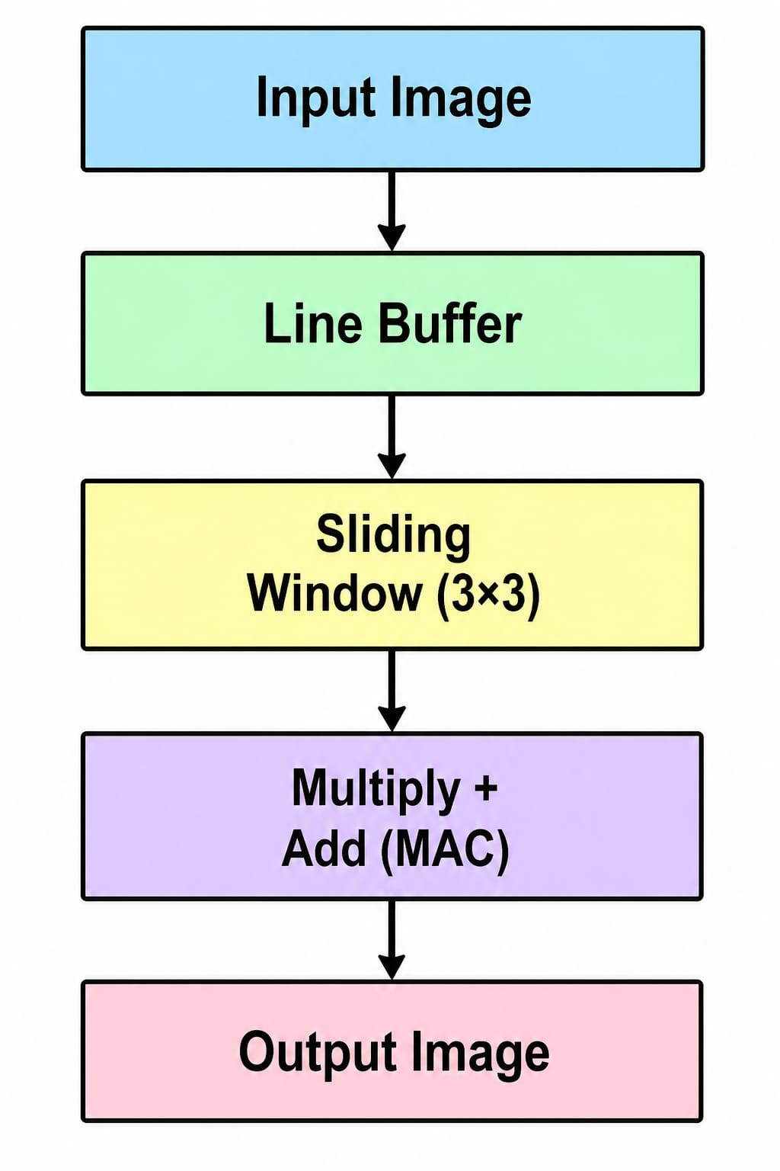

3.3 Architecture Diagram:

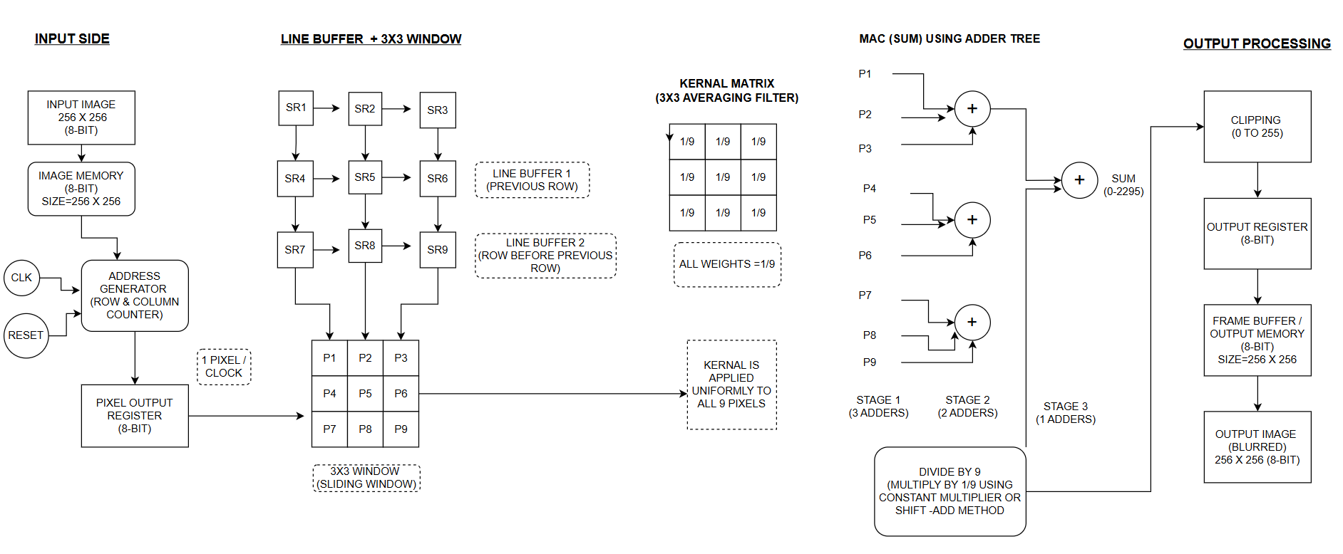

SECTION 1: INPUT SIDE
1. Input Image (256×256, 8-bit)
The system accepts a grayscale image of size 256×256 pixels, where each pixel holds an 8-bit value.
Pixel value range:
Total pixels: 256 \times 256 = 65,536 pixels

2. Image Memory (8-bit, Size = 256×256)
This is a RAM block that stores all pixel data. It is addressed using row and column indices.
Memory addressing:
256 × 256 = 65,536 pixels
Total memory size: 65,536 \times 8 = 524,288 bits = 64 KB

3.Address Generator (Row & Column Counter)
Driven by CLK (Clock) and RESET signals, this block generates sequential read addresses to fetch pixels one by one.

4.Pixel output register
Holds one pixel per clock cycle
Synchronizes data flow into processing pipeline

SECTION 2: LINE BUFFER + 3×3 SLIDING WINDOW:

This block collects a 3×3 group of pixels for filtering.
Since only 1 pixel arrives per clock, we store previous rows to access 3 rows at once.
Line Buffer 1: stores the previous row.
LB1[c] = Pixel[r-1][c]
Line Buffer 2: stores the row before that.
LB2[c] = Pixel[c-2][c]
Shift Registers (SR1–SR9):
These 9 registers form the 3×3 window.
At every clock:
Data shifts
Window moves one pixel to the right

3×3 Window Pixel Positions:
P1 = I[r-2][c-2]
P2 = I[r-2][c-1]
P3 = I[r-2][c]
P4 = I[r-1][c-2]
P5 = I[r-1][c-1]
P6 = I[r-1][c]
P7 = I[r][c-2]
P8 = I[r][c-1]
P9 = I[r][c]

SECTION 3: KERNEL MATRIX (3×3 Averaging Filter):

The averaging/box blur kernel assigns equal weight to all 9 pixels:
Because there are 9 pixels and each contributes equally to the average — this is the definition of a mean/box filter.
2D Convolution Formula:
O(r , c)=91​∑ I =−11​∑j=−11​I(r + I , c + j)
Where:
O(r, c) = Output blurred pixel at row r, column c
I(r + I , c +j) = Input neighbouring pixels
I , j∈{−1,0,1} represent the 3×3 neighbourhood positions
Full Expansion:
O(r , c) = (P1+P2+P3+P4+P5+P6+P7+P8+P9) / 9

SECTION 4: MAC (SUM) USING ADDER TREE:

Instead of adding all 9 values sequentially , an adder tree is used for parallel computation.
1.Input Pixels from 3×3 Window
P1,P2,P3,P4,P5,P6,P7,P8,P9.

2.Stage-wise Adder Tree
Stage 1
S1 = P1 + P2 + P3
S2 = P4 + P5 + P6
S3 = P7 + P8 + P9

Stage 2
S4 = S1 + S2
S5 = S3

Stage 3
SUM = S4 + S5

3.Final Blur output
Output = SUM / 9

4.Range of Sum
0 ≤ SUM ≤ 9 × 255 = 2295

SECTION 5: OUTPUT PROCESSING:

1. Clipping (0 to 255)
After division, enforce valid 8-bit range:
Clipping Formula:
O_ clipped = 0 if O < 0
O_ clipped = O if 0 ≤ O ≤ 255
O_ clipped = 255 if O > 255

2. Output Register (8-bit)
Holds the final computed blurred pixel value before writing to memory.
O_ reg = O_clipped[r][c]

3. Frame Buffer / Output Memory (8-bit, 256×256)
Stores the complete blurred output image as pixels are computed one by one.

OutputMemory [r][c] = O_ clipped(r, c)

4. Output Image (Blurred, 256×256, 8-bit)
The final result is a smoothed/blurred version of the original image where each pixel is the average of its 3×3 neighborhood.

Output Memory Size:
256 × 256 × 8 bits = 524,288 bits = 64 KB
Final Blurred Pixel Value:
O(r,c) = clamp((P1+P2+P3+P4+P5+P6+P7+P8+P9) / 9, 0, 255)
Total Output Pixels:
256 × 256 = 65,536 pixels
Output Bit Depth:
8 bits per pixel (same as input)
Output Image Size:
256 × 256 = 8-bit grayscale

Chapter 4: Leaf Cell Design

4.1 Identification of Leaf Cells:
1. D Flip-Flop (1-bit)
2. Shift Register (8-bit)
3. Full Adder (8-bit)
4. Output Register

4.2 Description of Leaf Cells:

- D Flip-Flop (1-bit):

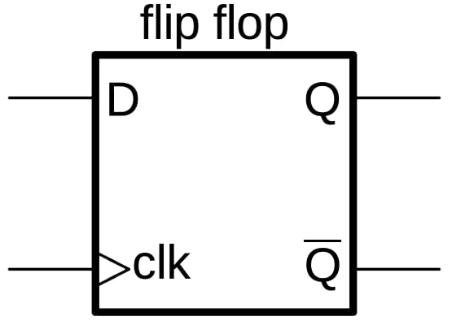
- Inside shift registers
- Inside output registers
- Everywhere data needs to be stored per clock

FORMULA:

Q(t+1)=D

2. Shift Register (8-bit):
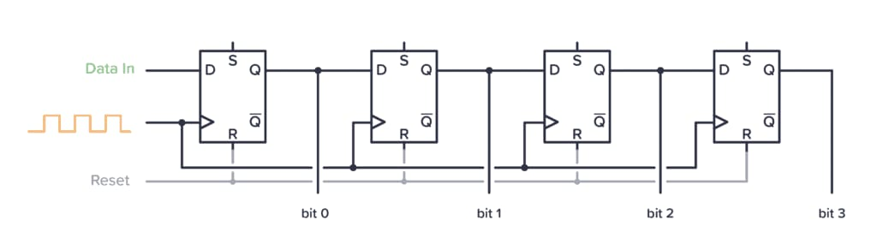

- To move pixel data step-by-step
- Forms part of sliding window

FORMULA:

Q(t+1)=Qi-1(t)

3. Full Adder (8-bit)

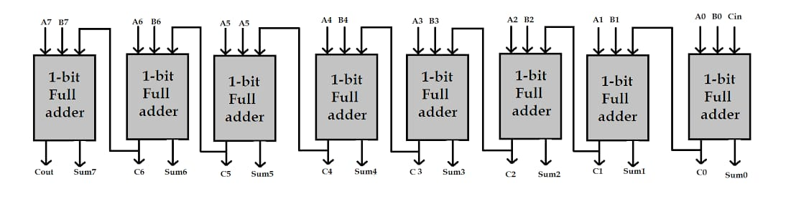

- It is inside the adder tree.
- Add 9 pixel values.
- Each pixel size is 8-bit

FORMULA:
Sum=A ^ B ^ Cin
Carry=A*B + B*Cin + A*Cin

4. Output Register

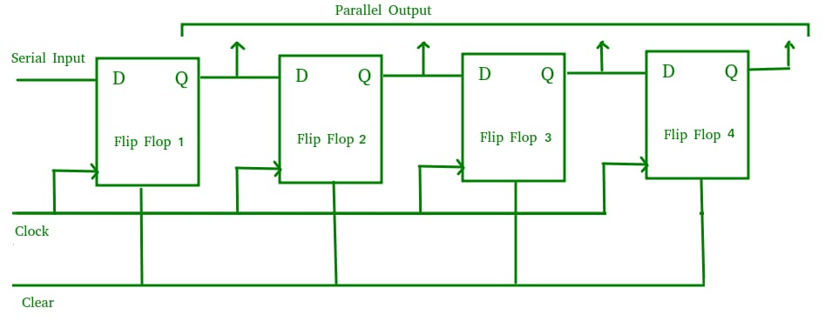
- To store the final blurred pixel
- Ensures stable & synchronized output
- It Removes glitches

FORMULA:

Q(t+1) = D

4.3 Leaf Cell Simulation:

D Flip-Flop (1-bit):
module D_ff(out_q,out_qbar,clk,reset,in_d);
input clk,reset,in_d;
output out_q,out_qbar;
reg out_q;
always @(posedge clk or posedge reset)

begin
if(reset)
out_q<=1'b0;
else
out_q<=in_d;
end
assign out_qbar=~out_q;
endmodule

TEST BENCH:
module D_ff_tb();
reg clk;
reg reset;
reg in_d;
wire out_q;
wire out_qbar;
D_ff d1(.clk(clk),.reset(reset),.in_d(in_d),.out_q(out_q),.out_qbar(out_qbar));
initial
begin
clk=1'b0;
forever
#5 clk=~clk;
end
initial
begin
$display("Time|clk|reset|in_d|out_q|out_qbar");
$monitor("%4d|%3b|%5b|%3b|%6b|%7b",$time,clk,reset,in_d,out_q,out_qbar);
reset=1'b1;in_d=1'b1;
#10;reset=1'b0;in_d=1'b0;
#10;in_d=1'b1;
#40;in_d=1'b0;
#40;in_d=1'b1;
#50 $finish;
end
endmodule
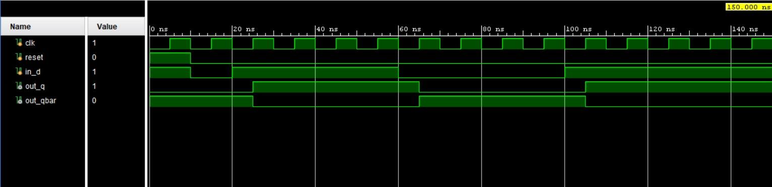

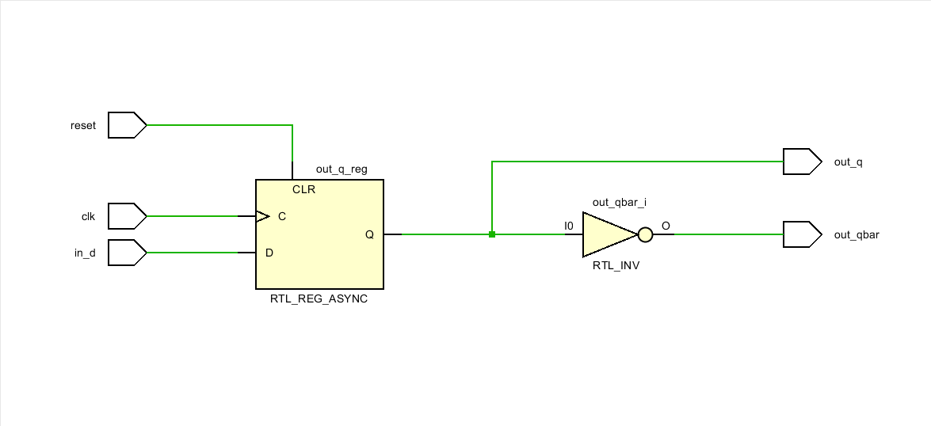

Shift Register (8-bit):

module shift_reg(
input clk,
input reset,
input din,
output reg [7:0] q
);

always @(posedge clk or posedge reset) begin
if (reset)
q <= 8'b00000000;
else
q <= {q[6:0], din};
end

endmodule

TEST BENCH:
module shift_reg_tb();

reg clk, reset, din;
wire [7:0] q;

shift_reg uut(clk, reset, din, q);

// clock generation
always #5 clk = ~clk;

initial begin
clk = 0;
reset = 1;
din = 0;

#10 reset = 0; // release reset properly

#10 din = 1;
#10 din = 0;
#10 din = 1;
#10 din = 1;
#10 din = 0;
#10 din = 1;
#10 din = 0;
#10 din = 1;

#40 $finish;
end
initial begin
$monitor("Time=%0t | reset=%b din=%b q=%b",
$time, reset, din, q);
end

endmodule

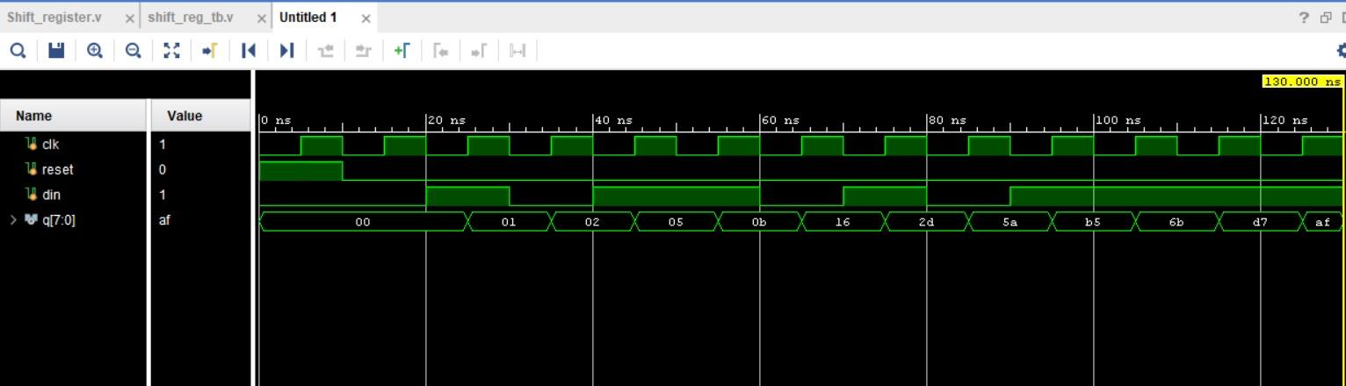

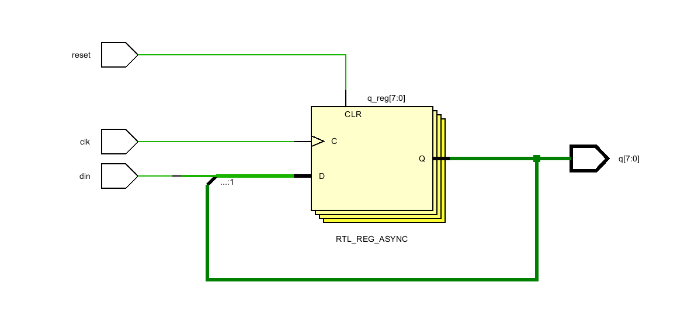

ADDER 8 - BIT

module full_adder (
input a, b, cin,
output sum, cout
);

assign sum = a ^ b ^ cin;
assign cout = (a & b) | (b & cin) | (a & cin);

endmodule

module adder8_bit (output [7:0] Sum,
output Cout,
input [7:0] A,
input [7:0] B,
input Cin

);

wire [6:0] carry;

full_adder FA0 (A[0], B[0], Cin, Sum[0], carry[0]);
full_adder FA1 (A[1], B[1], carry[0], Sum[1], carry[1]);
full_adder FA2 (A[2], B[2], carry[1], Sum[2], carry[2]);
full_adder FA3 (A[3], B[3], carry[2], Sum[3], carry[3]);
full_adder FA4 (A[4], B[4], carry[3], Sum[4], carry[4]);
full_adder FA5 (A[5], B[5], carry[4], Sum[5], carry[5]);
full_adder FA6 (A[6], B[6], carry[5], Sum[6], carry[6]);
full_adder FA7 (A[7], B[7], carry[6], Sum[7], Cout);
endmodule

TEST BENCH:
module adder8_bit_tb;
reg [7:0] A;
reg [7:0] B;
reg Cin;
wire [7:0] Sum;
wire Cout;
adder8_bit uut (
.A(A),
.B(B),
.Cin(Cin),
.Sum(Sum),
.Cout(Cout)
);

initial
begin
$monitor("Time=%0t | A=%d B=%d Cin=%b | Sum=%d Cout=%b",
$time, A, B, Cin, Sum, Cout);

A = 0; B = 0; Cin = 0; #10;
A = 10; B = 20; Cin = 0; #10;
A = 50; B = 25; Cin = 1; #10;
A = 100; B = 155; Cin = 0; #10;
A = 255; B = 1; Cin = 0; #10;
A = 200; B = 100; Cin = 1; #10;

$finish;
end
endmodule
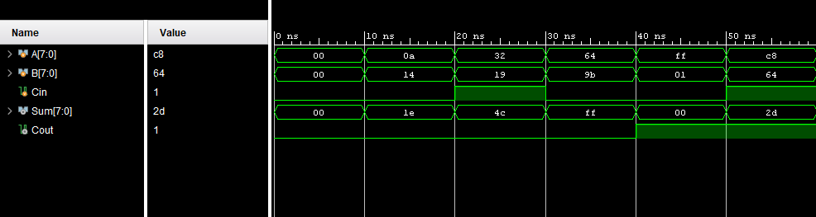

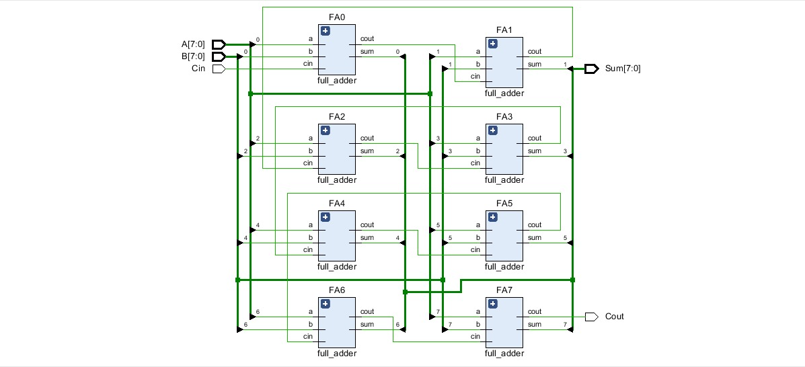

OUTPUT REGISTER

module output_reg (output reg [7:0] data_out,
input clk,
input reset,
input [7:0] data_in);

always @(posedge clk or posedge reset) begin
if (reset)
data_out <= 8'b00000000;
else
data_out <= data_in;
end
endmodule

TEST BENCH :

module output_reg_tb;
reg clk;
reg reset;
reg [7:0] data_in;
wire [7:0] data_out;

output_reg uut (
.clk(clk),
.reset(reset),
.data_in(data_in),
.data_out(data_out));

always #5 clk = ~clk;

initial
begin
$monitor("Time=%0t | reset=%b data_in=%d | data_out=%d",
$time, reset, data_in, data_out);

clk = 0;
reset = 1;
data_in = 0;
#10;

reset = 0;
data_in = 8'd10; #10;
data_in = 8'd25; #10;
data_in = 8'd50; #10;
reset = 1; #10;
reset = 0;
data_in = 8'd100; #10;
data_in = 8'd200; #10;
$finish;
end
endmodule

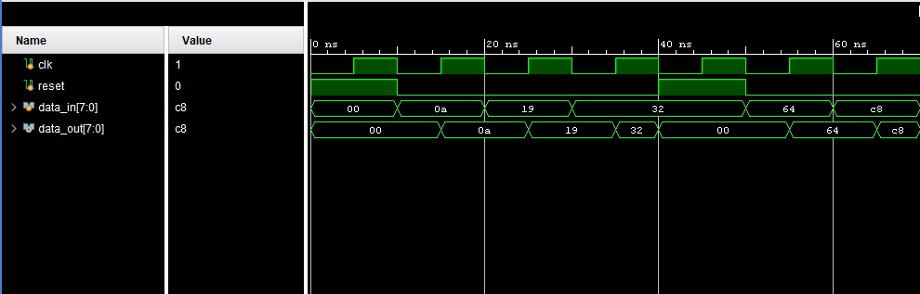

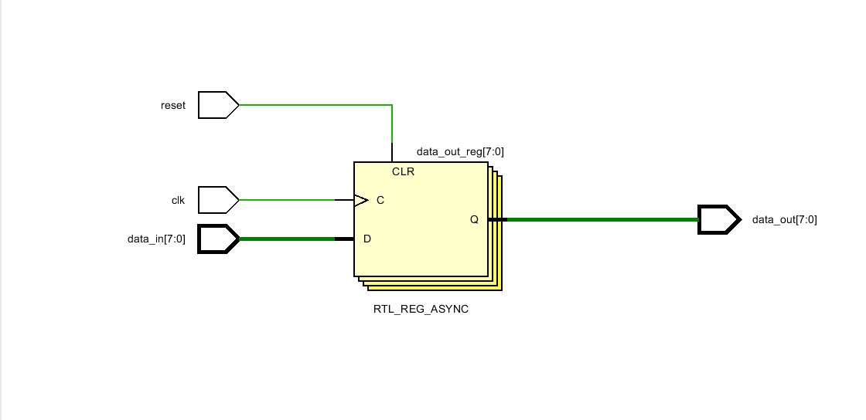

TOOLS USED:
- Xilinx vivado
- Verilog hdl
- Diagrams.net(draw.io)

References:
FPGA 2D-Convolution unit based on the CAPH language. It focuses on using parallel computation and matrix operations to efficiently process signals or images. Real-time image processing with a compact FPGA based systolic architecture. It achieves high speed and performance by exploiting data parallelism and reducing memory access overhead, making it suitable for applications like convolution and image filtering
A high performance fully reconfigurable FPGA based 2D convolution processor.
It uses parallel SIMD architecture and run-time reconfigurability to process different resolutions and kernel sizes efficiently without reprogramming the hardware.Hardware implementation of 2D convolution on FPGA:It uses techniques like pipelining and parallel processing to increase speed and reduce computation time, achieving higher throughput.Fast hardware architecture for 2D separable convolution operations:The paper proposes FPGA-based architectures (SWSC and MWSC) using distributed arithmetic to achieve faster, real-time processing with improved performance and efficient hardware utilization.

